TITLE: Smart Book Tracker – Tracks Progress and Location of Books
ABSTRACT
This project presents Smart Book Tracker – Tracks Progress and Location of Books, an intelligent book management system designed to help users efficiently organize, monitor, and track books along with reading progress information. The system uses RFID or barcode-based identification technology integrated with a microcontroller and database system to maintain digital records of books and their storage locations. Users can update reading progress, check availability status, and identify the physical location of books through a desktop or mobile application.
The system scans books using RFID/barcode modules and stores information such as book title, author details, shelf location, reading percentage, and borrowing status in a local or cloud database. The stored information can be accessed through an application interface that allows users to search books, manage reading records, and generate reports regarding reading activity and book location history.
The Smart Book Tracker improves personal library management, reduces the time required to search for books, and supports organized reading habits. The project combines embedded systems, database management, RFID/barcode technology, and software integration to provide a smart, user-friendly, and efficient book tracking solution for homes, libraries, schools, and educational institutions.

Date :
Signature :
Name : Janardhan

TITLE: Smart Book Tracker – Tracks Progress and Location of Books
PREAMBLE TO THE DESCRIPTION
THE FIELD OF INVENTION
This invention relates to the field of smart book management and tracking systems, specifically utilizing RFID/barcode identification technology, embedded systems, and database integration for tracking book location and reading progress. The invention integrates automated book identification, digital record maintenance, and software-based monitoring to improve library organization and reading management systems.

BACKGROUND OF THE INVENTION
Traditional book management methods mainly depend on manual record keeping and physical searching, which can be time-consuming and inefficient. Readers often forget their reading progress or misplace books in different storage locations. Existing systems generally focus only on basic library management and do not provide integrated reading progress tracking and location identification features. Therefore, there is a need for a smart and automated book tracking system capable of monitoring reading progress and identifying the storage location of books efficiently.

SUMMARY OF THE INVENTION
Smart Book Tracker – Tracks Progress and Location of Books is an intelligent book monitoring system designed for automated book identification, reading progress tracking, and location management. The system uses RFID/barcode technology integrated with a microcontroller and database platform to monitor book details and user reading activity. The collected information is stored in a database and displayed through a desktop or mobile application where users can search books, update reading progress, and monitor book locations. The invention improves book organization, supports efficient reading management, and reduces the time required for locating books.

Date :
Signature :
Name : Janardhan
TITLE: Smart Book Tracker – Tracks Progress and Location of Books
COMPLETE SPECIFICATION
Specifications
Hardware Specifications:
• RFID Reader / Barcode Scanner
Scans and identifies books using RFID tags or barcode labels.
• ESP32 / Arduino Microcontroller
Acts as the central processing unit and manages data collection and communication.
• RFID Tags / Barcode Labels
Attached to books for unique identification and tracking.
• LCD / OLED Display
Displays book details, reading status, and notifications.
• WiFi / Bluetooth Module
Enables wireless communication between hardware and application systems.
• Local Storage / SD Card Module
Stores temporary book records and transaction details.
• Power Supply Unit
Provides stable power for continuous operation of the tracking system.

Software Specifications:
• Embedded Programming :
Embedded C/C++ or Python is used for programming the microcontroller and processing book data.
• Database Integration :
MySQL, Firebase, or cloud databases are used to store book records and reading history.
• Desktop / Mobile Application :
Allows users to search books, update reading progress, and monitor location information.
• Communication Protocol :
HTTP, MQTT, Bluetooth, or WiFi communication enables data transfer between hardware and software platforms.
• Reading Progress Monitoring :
Tracks current reading status, completed pages, and reading analytics.
• Security Implementation :
Authentication and secure database handling provide protected access to user records.

Environmental Specifications:
- Operating Temperature: 0°C to 45°C
- Humidity: 10% to 85% Relative Humidity
- Power Supply: 5V DC Supply
- Indoor Condition: Suitable for homes, schools, libraries, and office environments.

Date :
Signature :
Name : N. Janardhan

TITLE: Smart Book Tracker – Tracks Progress and Location of Books

DESCRIPTION

The Smart Book Tracker – Tracks Progress and Location of Books is an intelligent management system that integrates RFID/barcode technology, embedded systems, database management, and software applications for efficient book monitoring and reading progress tracking. The system scans books using RFID readers or barcode scanners and stores information such as title, author, storage location, reading progress, and availability status in a centralized database.

The collected information is processed using a microcontroller and synchronized with desktop or mobile applications through WiFi/Bluetooth communication. Users can search for books, update reading progress, check storage locations, and generate reading activity reports using the application interface. The system also helps in identifying misplaced books and maintaining organized storage arrangements.

Designed for students, libraries, educational institutions, and personal book collections, the Smart Book Tracker improves reading management efficiency, reduces manual record maintenance, and provides an automated solution for tracking books and reading activity.

BLOCK DIAGRAM
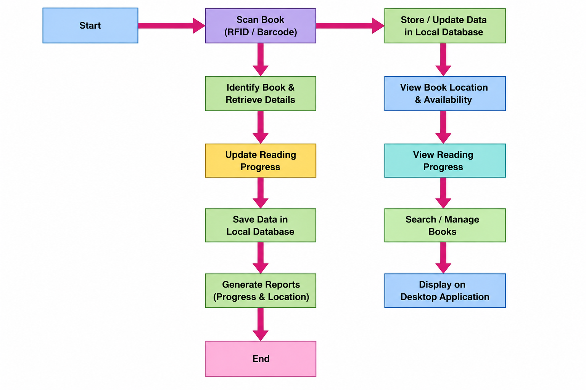

Date :
Signature :
Name :N. Janardhan

TITLE: Smart Book Tracker – Tracks Progress and Location of Books
CLAIM
We claimed:
- A smart book tracking system that uses RFID/barcode-based identification technology to monitor book location and reading progress in real time.
- A reading progress monitoring system integrated with a database platform to store and manage user reading activity and book records.
- A wireless communication system using ESP32/Arduino-enabled modules for transmitting book information to desktop or mobile applications.
- A book management platform configured to identify book location, availability status, and storage details automatically.
- A database-integrated tracking system designed to generate reports regarding reading progress, book history, and location analytics.
In essence, we claimed:
- RFID/barcode-based identification is used for automated book tracking and management.
- The system includes desktop/mobile integration for monitoring reading progress and book location.
- It uses database storage and wireless communication for efficient data management and synchronization.
- An intelligent smart tracking setup ensures organized book management and automated reading activity monitoring.

Date :
Signature :
Name :N. Janardhan

